# **Requirement**

In Transaction CKM3N Header Values of Actual Cost (Quantity * Actual Price) must match with the roll up cost of Lines. Currently Header & Line item cost roll up is not matching. We are aware of OSS Note 1884961 & 1004597.

Can you please help us find the Actaul Cost of Exploded BOM.

**Step 1**

Enter Transaction Code CKM3N

**Step 2**

Input Values for Material, Plant & Period/Year & Click Enter button

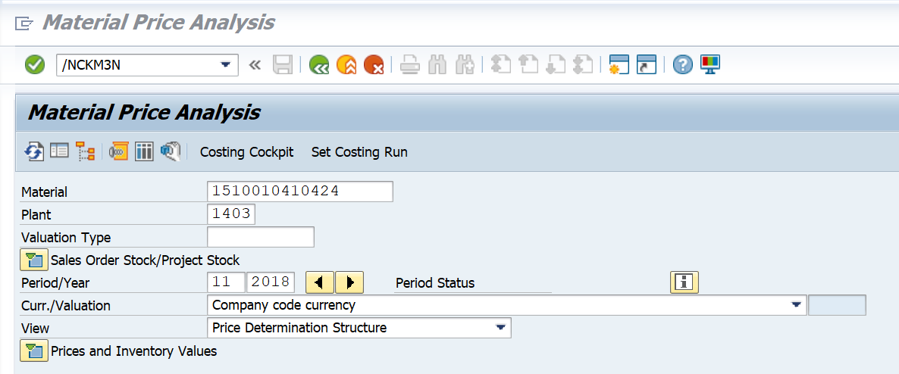

**Step 3**

Click on Shift+F8 for getting BOM Structure.

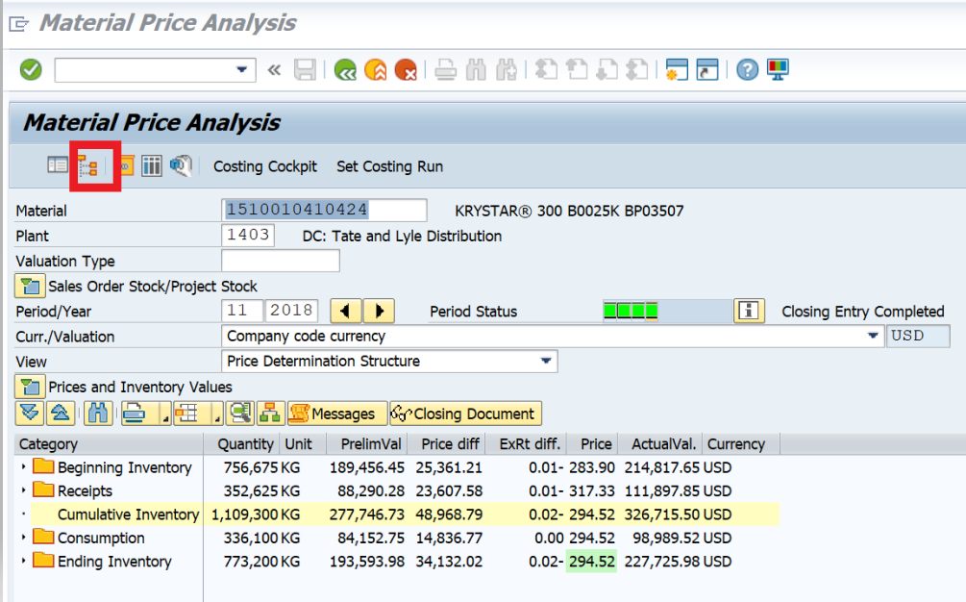

Header and Line item cost roll up is not matching.

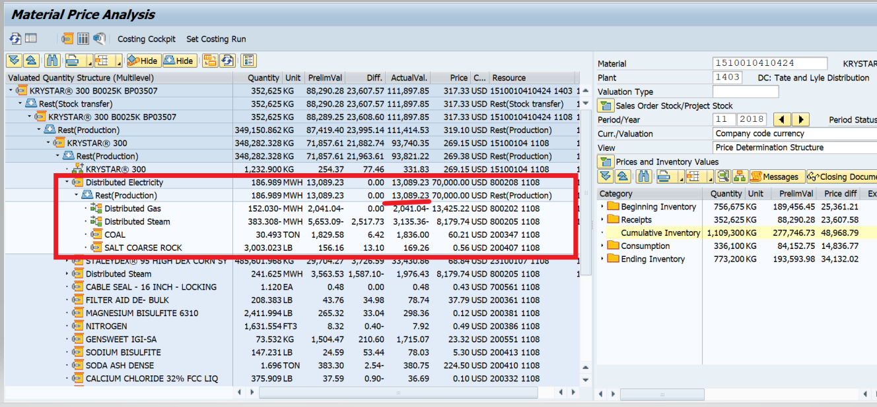

## **SAP OSS Note on the Issue.**

NOTE : 1884961

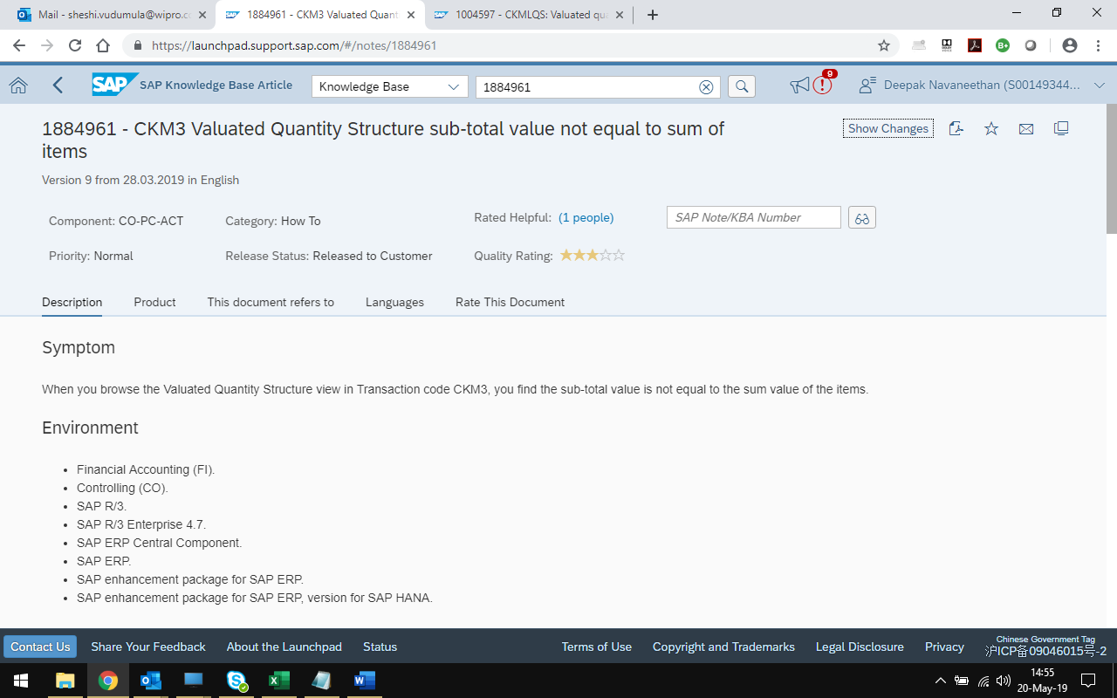

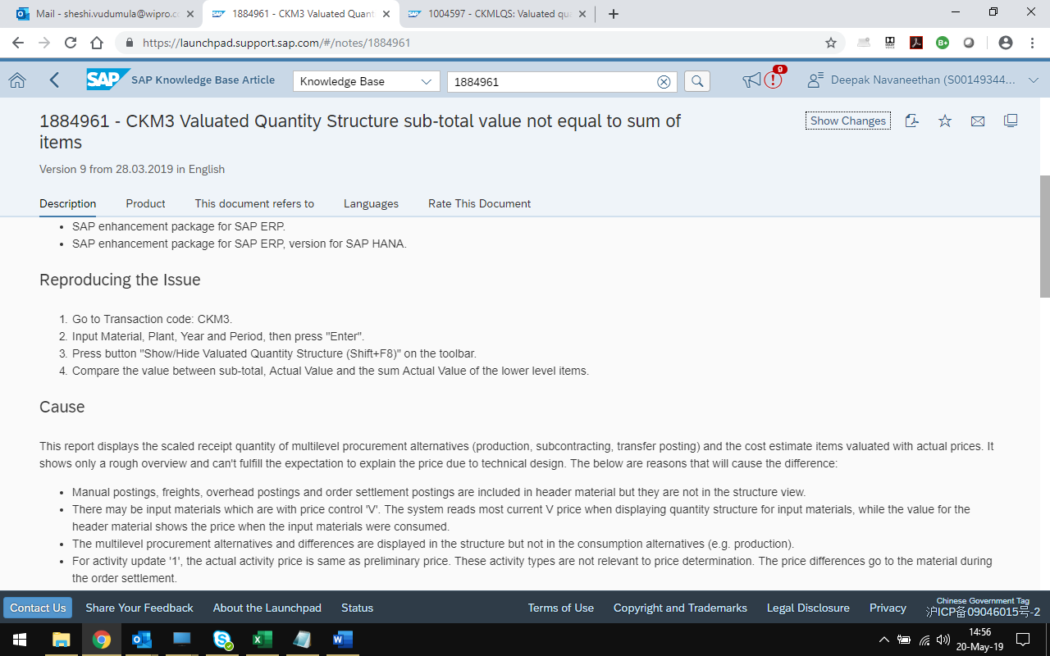

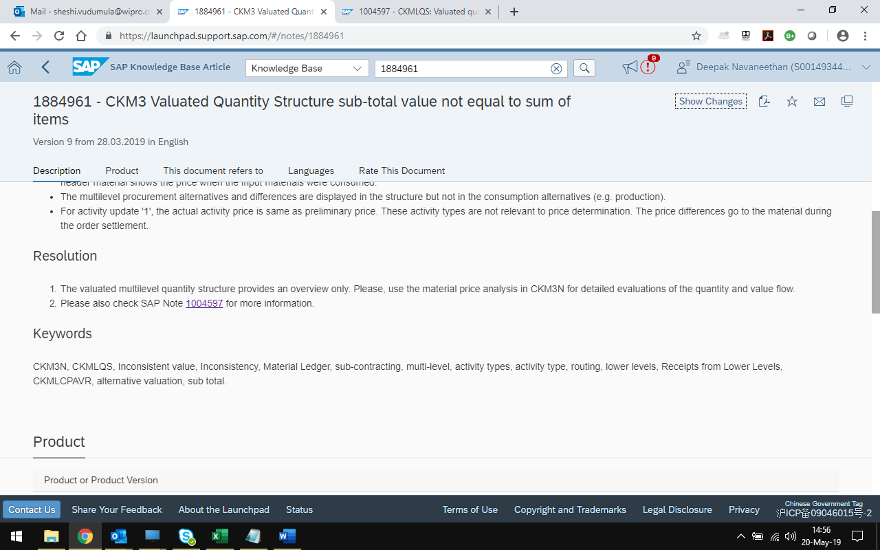

NOTE : 1004597

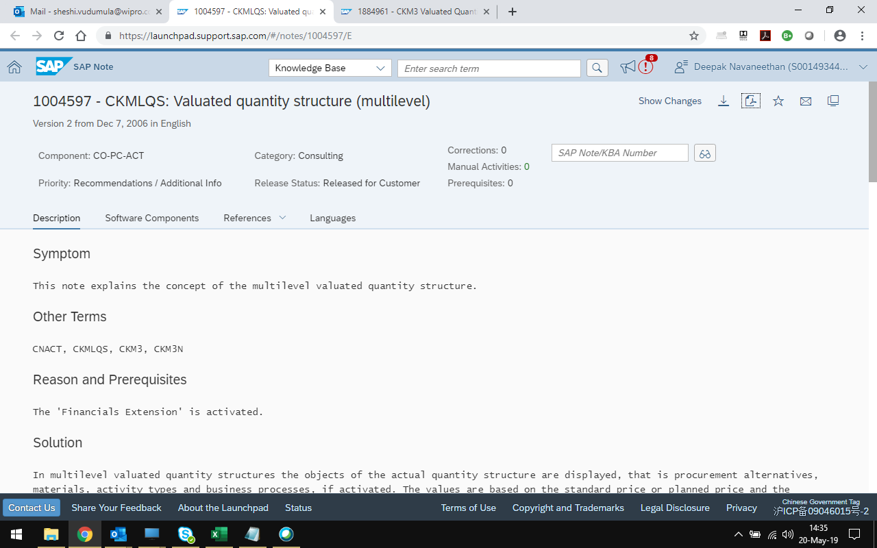

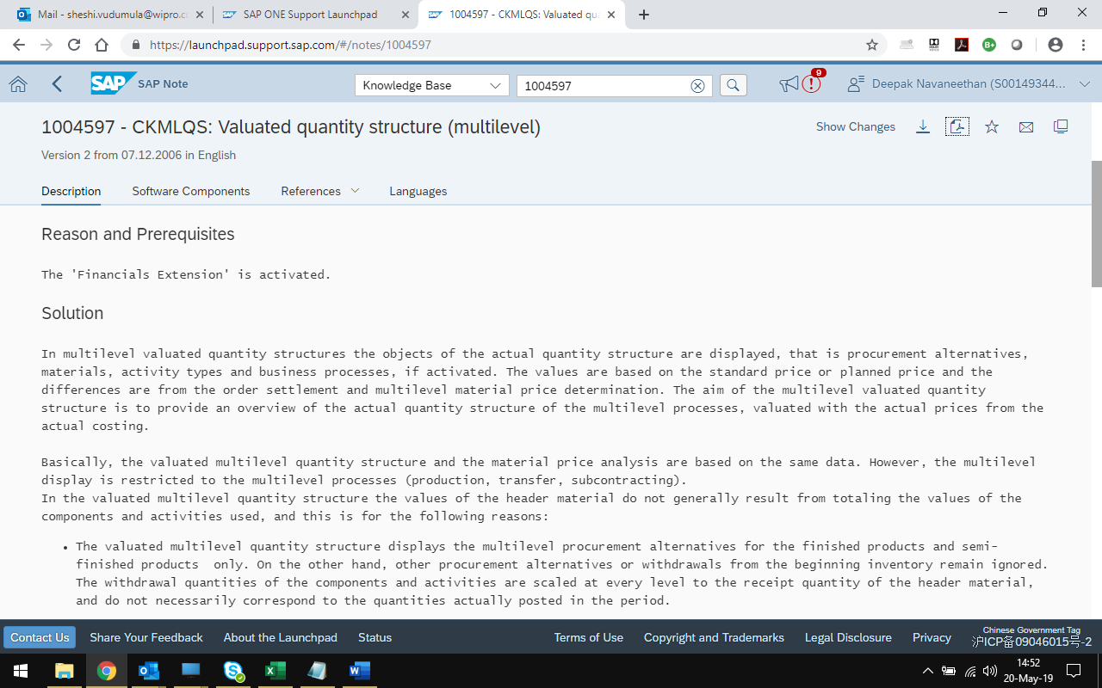

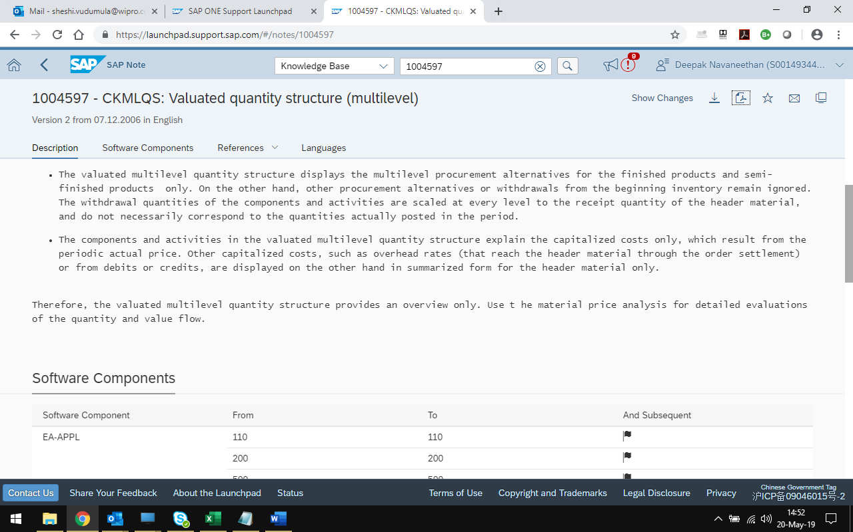

## **SAP Material Ledger & Actual Costing Configuration**

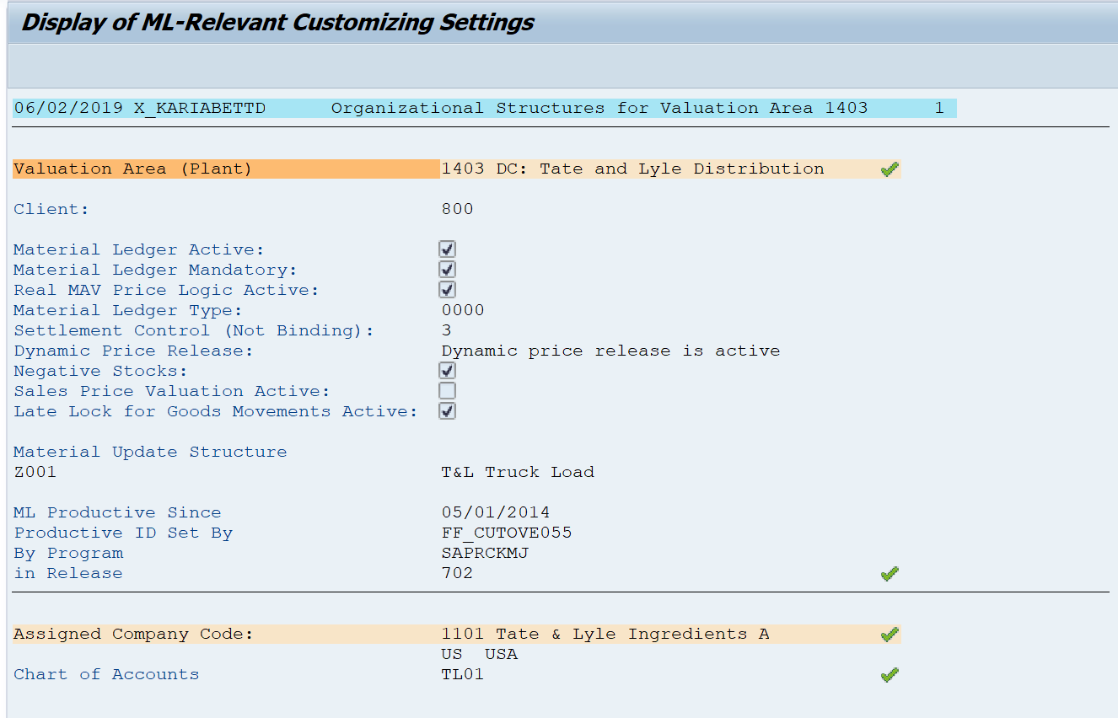

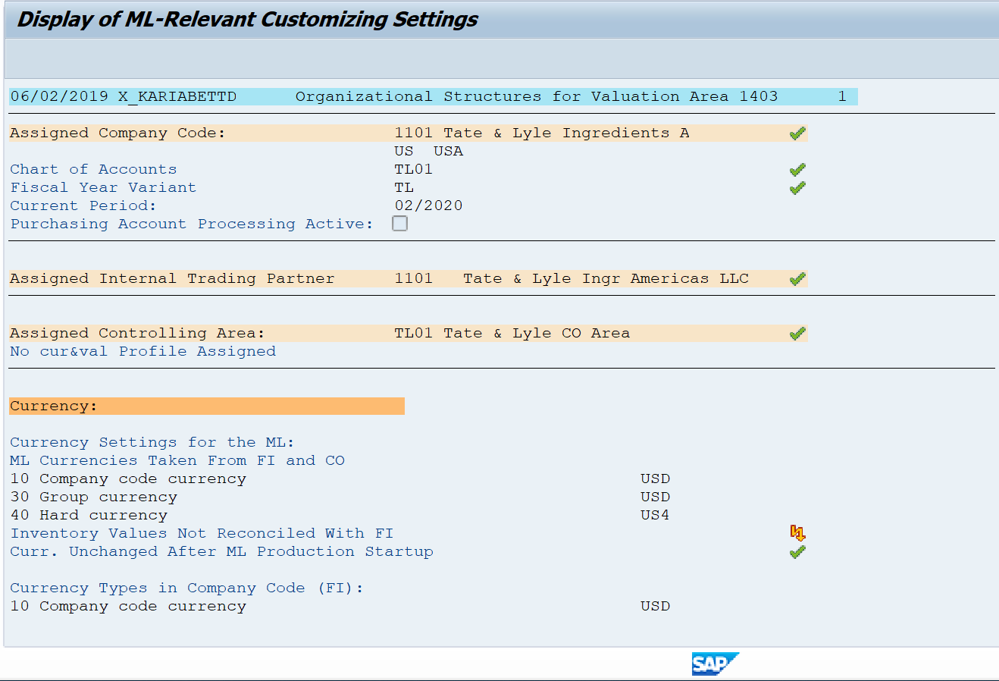

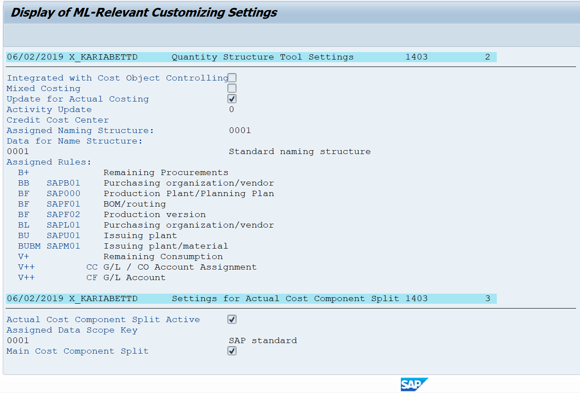

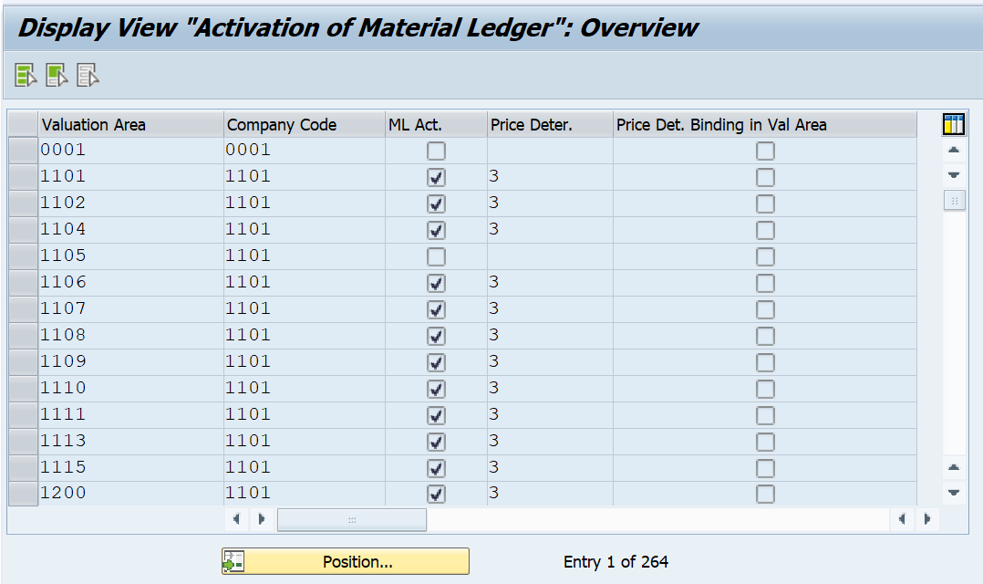

## **Tate & Lyle SAP system**

